AI-Driven Analysis of Screen Time and Social Interaction to Detect Social Isolation

# 1st R Krithiga

*Department of Computer Science and Engineering Vellore Institute of Technology*

Chennai, India [krithig](https://ieeexplore.ieee.org/abstract/document/9871331/)[a.r@vit.ac.in](mailto:a.r@vit.ac.in)

# 3rd K.C.Jyothi Swaroopa

2nd Gunnam Deekshitha

*Department of Computer Science and Engineering Vellore Institute of Technology*

Chennai, India [gunnam.deekshitha2022@vitstudent.ac.in](https://www.sciencedirect.com/science/article/pii/S001393512202494X)

# 4th Dasari Yaswanth sai

*Department of Computer Science and Engineering Vellore Institute of Technology*

Chennai, India [jyothisw](https://www.tandfonline.com/doi/abs/10.1080/00330124.2021.1970591)[aroopa.kc2022@vitstudent.ac.in](https://www.sciencedirect.com/science/article/pii/S1053811917310686)

*Department of Computer Science and Engineering Vellore Institute of Technology*

Chennai, India [dasariyasw](mailto:dasariyaswanth.sai2022@vitstudent.ac.in)[anth.sai2022@vitstudent.ac.in](https://www.tandfonline.com/doi/abs/10.1080/00330124.2021.1970591)

***Abstract*—Social isolation is becoming an increasingly signifi- cant issue in modern society, exacerbated by the growing influ- ence of technology. This paper proposes an AI-driven approach to analyze screen time and social interactions to detect social isolation patterns among individuals. Using machine learning models, including Random Forest and Deep Neural Networks, the system identifies signs of social isolation by analyzing social media engagement, communication frequency, and screen time behaviors. This paper outlines the design, methodology, and evaluation of the proposed solution, with a focus on the potential impact on early detection and intervention for individuals at risk of isolation.**

***Index Terms*—AI, Machine Learning, Social Isolation, Screen Time, Social Media, Deep Neural Networks, Random Forest, Early Detection**

1. INTRODUCTION

Social isolation is a growing concern, particularly among individuals who spend significant amounts of time on digital platforms, yet have minimal face-to-face interaction. With the advent of social media and mobile communication technolo- gies, it has become increasingly easy for people to interact in virtual spaces. However, these interactions often lack the depth and emotional connection that come from in-person communication. This discrepancy has led to an increase in loneliness and social isolation, especially among vulnerable populations, including teenagers, the elderly, and those with mental health disorders.

The impact of social isolation on mental health is well- documented, with studies showing correlations between pro- longed isolation and increased risks of depression, anxiety, and other mental health issues. The challenge lies in identifying the early signs of social isolation before it becomes severe. Traditional methods of assessing social isolation rely on sur- veys and self-reports, which may be unreliable or biased. This paper proposes an AI-driven approach that uses data derived

Identify applicable funding agency here. If none, delete this.

from digital interactions—such as screen time, social media usage, and communication patterns—to detect early indicators of isolation.

Machine learning (ML) and artificial intelligence (AI) have proven to be powerful tools in analyzing complex behavioral data. By employing various machine learning algorithms, including Random Forest (RF), Support Vector Machines (SVM), and Deep Neural Networks (DNN), this study aims to identify patterns in users’ digital behaviors that are indicative of social isolation. The proposed system not only monitors screen time and social media interactions but also tracks the frequency and nature of communications (e.g., text messages, calls, and social media posts) to assess whether these interac- tions are meaningful or superficial.

The goal of this system is to provide early warnings to in- dividuals or health professionals, enabling timely intervention. By identifying isolation patterns early, it becomes possible to implement targeted interventions, such as increasing social support or promoting offline interactions, which can signifi- cantly improve the quality of life for individuals at risk of social isolation.

1. *Objectives*

The main objectives of this paper are as follows:

* + To develop a machine learning-based model that can an- alyze screen time, social media interactions, and commu- nication patterns to detect early signs of social isolation.
  + To compare the performance of different machine learn- ing algorithms (RF, SVM, and DNN) in detecting social isolation.
  + To evaluate the potential impact of early detection of social isolation on mental health outcomes.

1. *Abbreviations and Acronyms*

In this paper, we define the following abbreviations and acronyms as they are used throughout the text:

These abbreviations will be used throughout the paper, and all of them are defined at their first occurrence.

1. *Units*

In this paper, we primarily use standard units for time, data, and machine learning metrics. Below are the units that will be used for different types of measurements:

* + **Time:** All time-related metrics, including screen time, social media interaction time, and communication dura- tions, are expressed in **seconds (s)**, **minutes (min)**, or **hours (h)**.
  + **Data Storage:** Data volumes, such as the amount of data consumed in social media or mobile usage, are represented in **bytes (B)**, **kilobytes (KB)**, or **megabytes (MB)**.
  + **Machine Learning Performance:** Performance metrics such as accuracy, precision, recall, and F1-score are expressed as **percentages (%)**.
  + **Statistical Units:** Statistical metrics such as mean, vari- ance, and standard deviation are calculated in the relevant units, including **percentages (%)** for analysis of engage- ment or isolation rates.
  + **Evaluation Metrics:** Performance evaluation in machine learning is done using **accuracy**, **precision**, **recall**, **F1- score**, and **AUC**, expressed in **percentages (%)**.
  + **Communication Frequency:** The frequency of commu- nication (calls, messages, posts) is recorded in **counts** or **occurrences** per day, week, or month.
  + **Other Units:** Other physical units (if applicable, e.g., for sensor data or environmental conditions) will be specified where used.

[12pt]article amsmath graphicx hyperref

1. PROBLEM DEFINITION AND DATA COLLECTION The objective of this project is to predict social isolation

based on behavioral data, such as screen time, communication

frequency, and social interaction metrics. The Random Forest model will be used to classify individuals as socially isolated or not based on these features.

*A. Data Collection*

Data is collected from various sources, including smart- phone usage logs, social media activity, and sensor data (if available). Features such as **screen time**, **communication frequency**, and **interaction patterns** are extracted from the raw data. The dataset is labeled with two classes: *isolated* and *non-isolated* individuals.

1. DATA PREPROCESSING

The data undergoes several preprocessing steps to ensure quality and usability:

1. *Handling Missing Data*

Missing or incomplete data points are handled by:

* + **Imputation**: Fill missing values using the mean, median, or mode for continuous features.
  + **Dropping Rows/Columns**: If the missing data is signif- icant, the affected rows or columns are removed.

1. *Feature Engineering*

Features extracted from the dataset include:

* + **Screen Time** (*T*screen): The total time spent on a device or application per day.
  + **Communication Frequency** (*F*interaction): The number of interactions or messages sent and received during a specified time period.
  + **Social Interaction Score**: Derived from the frequency and quality of interactions on social media or with other individuals.

1. *Normalization/Scaling*

Features are normalized or scaled to ensure that they are on a similar scale, which is crucial for models like Random Forest. Methods like **Min-Max Scaling** or **Standardization** can be applied.

1. SPLITTING THE DATA

The dataset is divided into training and testing sets. Typi- cally, an 80/20 ratio is used, where:

* + 80% of the data is used for training the model.
  + 20% is held out for testing the model’s performance.

**Cross-validation** may also be used to assess the model’s robustness.

1. MODEL TRAINING: RANDOM FOREST CLASSIFIER
2. *Random Forest Algorithm*

Random Forest is an ensemble learning method where multiple decision trees are trained on different subsets of the data. Each tree in the forest is trained independently using a random subset of the training data and random subsets of features for each split. The final prediction is made based on the majority voting (for classification tasks) across all trees.

1. *Steps in Random Forest Training*

The Random Forest model is trained through the following steps:

* + **Bootstrapping**: Randomly select subsets of the training data with replacement (bootstrap sampling).
  + **Feature Selection**: At each split, a random subset of features is considered for the best possible split.
  + **Building Multiple Decision Trees**: A large number of decision trees are built independently using different random subsets of the data and features.
  + **Voting for Prediction**: Each tree casts a vote, and the class with the most votes is selected as the final prediction.

1. *Hyperparameter Tuning*

Key hyperparameters are adjusted for better performance:

* + **Number of Trees** (*n*trees): The total number of decision trees in the forest.
  + **Max Depth**: The maximum depth of each tree.
  + **Min Samples Split**: The minimum number of samples required to split an internal node.
  + **Max Features**: The maximum number of features con- sidered for splitting at each node.

1. MODEL EVALUATION

The performance of the Random Forest model is evaluated on the test set using the following evaluation metrics:

* + **Accuracy**: The percentage of correctly classified in- stances.
  + **Precision**: The proportion of positive instances correctly classified as positive.
  + **Recall (Sensitivity)**: The proportion of actual positive instances correctly identified by the model.
  + **F1-Score**: The harmonic mean of precision and recall, providing a balance between them.
  + **Confusion Matrix**: Displays the true positives, false positives, true negatives, and false negatives.

The formulas for these metrics are:

True Positives + True Negatives

1. PROBLEM DEFINITION AND DATA COLLECTION

The objective of this project is to predict social isolation based on behavioral data, such as screen time, communication frequency, and social interaction metrics. The Random Forest model will be used to classify individuals as socially isolated or not based on these features.

*A. Data Collection*

Data is collected from various sources, including smart- phone usage logs, social media activity, and sensor data (if available). Features such as **screen time**, **communication frequency**, and **interaction patterns** are extracted from the raw data. The dataset is labeled with two classes: *isolated* and *non-isolated* individuals.

Accuracy =

Total Samples

1. DATA PREPROCESSING

Precision = True Positives True Positives + False Positives

Recall = True Positives True Positives + False Negatives

F1-Score = 2 Precision *×* Recall

*×*

Precision + Recall

* 1. FEATURE IMPORTANCE

Random Forest provides feature importance metrics, in- dicating which features (e.g., screen time, communication frequency) are most influential in making predictions. Feature importance is calculated based on how much each feature reduces the impurity in the decision trees:

*n*trees

Σ 1

Feature Importance = ∆*G*impurity

*n*trees *i*=1

Where ∆*G*impurity represents the reduction in impurity for a given feature in each tree.

* 1. MODEL DEPLOYMENT

Once the Random Forest model is trained and evaluated, it can be deployed in a real-world application. The model can be integrated into a system that collects real-time behavioral data (screen time, interaction frequency) and makes predictions about social isolation on an ongoing basis.

* 1. RESULTS INTERPRETATION AND ACTIONABLE INSIGHTS

The predictions from the Random Forest model are analyzed to provide actionable insights. For example, if an individual is predicted to be socially isolated, the system could suggest interventions, such as recommending more frequent social interactions or monitoring their activity.

**Model Improvement**: Future work may involve refining the model by incorporating additional features, hyperparameter tuning, or exploring other machine learning algorithms.

[12pt]article amsmath graphicx hyperref

The data undergoes several preprocessing steps to ensure quality and usability:

1. *Handling Missing Data*

Missing or incomplete data points are handled by:

* + **Imputation**: Fill missing values using the mean, median, or mode for continuous features.
  + **Dropping Rows/Columns**: If the missing data is signif- icant, the affected rows or columns are removed.

1. *Feature Engineering*

Features extracted from the dataset include:

* + **Screen Time** (*T*screen): The total time spent on a device or application per day.
  + **Communication Frequency** (*F*interaction): The number of interactions or messages sent and received during a specified time period.
  + **Social Interaction Score**: Derived from the frequency and quality of interactions on social media or with other individuals.

1. *Normalization/Scaling*

Features are normalized or scaled to ensure that they are on a similar scale, which is crucial for models like Random Forest. Methods like **Min-Max Scaling** or **Standardization** can be applied.

1. *Handling Outliers*

Outliers in the data are detected and handled to ensure that they do not skew the model. This can be done by:

* + **Z-Score Method**: Identifying outliers that are far from the mean by using Z-scores.
  + **IQR Method**: Identifying and removing outliers based on the interquartile range.

1. *Splitting Data into Training and Testing Sets*

After preprocessing, the data is split into training and testing sets. This is done to evaluate the model’s performance on unseen data:

* + **Training Set**: Typically 80% of the data is used for training the model.
  + **Testing Set**: The remaining 20% is used for evaluating the model.
    1. MODEL TRAINING AND EVALUATION

A well-structured approach was used to train and evaluate the Random Forest model for detecting social isolation. Below, the methodology is divided into distinct subparts:

1. *Random Forest Model Training*

The Random Forest algorithm, an ensemble learning method, was selected for its robustness in handling structured data. The training process involved the following steps:

* + **Feature Selection:** Features such as screen time, com- munication frequency, and social interaction score were chosen based on their importance in predicting social isolation.
  + **Hyperparameter Configuration:** Key hyperparameters like the number of trees (n_estimators), maximum tree depth (max_depth), and minimum samples split (min_samples_split) were optimized using grid search.
  + **Bootstrap Aggregation:** The model utilized bootstrapped samples to create multiple decision trees, ensuring diver- sity and reduced variance.

1. *Cross-Validation*

To ensure the model’s generalizability, a *k*-fold cross- validation approach was implemented:

* + **Splitting Data:** The dataset was divided into *k* = 10 folds, with each fold serving as a validation set while the remaining *k −* 1 folds formed the training set.
  + **Evaluation Metrics:** The model’s performance was aver- aged across all folds, providing insights into its stability and reliability.

1. *Performance Metrics*

The following metrics were used to evaluate the Random Forest model:

* + **Accuracy:** The ratio of correctly predicted labels to the total number of predictions.
  + **Precision:** The proportion of true positive predictions to the total predicted positives.

*True Positives True Positives*+*False Positives*

*Precision* =

* + **Recall (Sensitivity):** The proportion of true positives

identified among all actual positives.

*True Positives True Positives*+*False Negatives*

*Recall* =

* + **F1 Score:** The harmonic mean of precision and recall,

balancing false positives and false negatives.

*Precision Recall Precision*+*Recall*

*F* 1 = 2 *· ·*

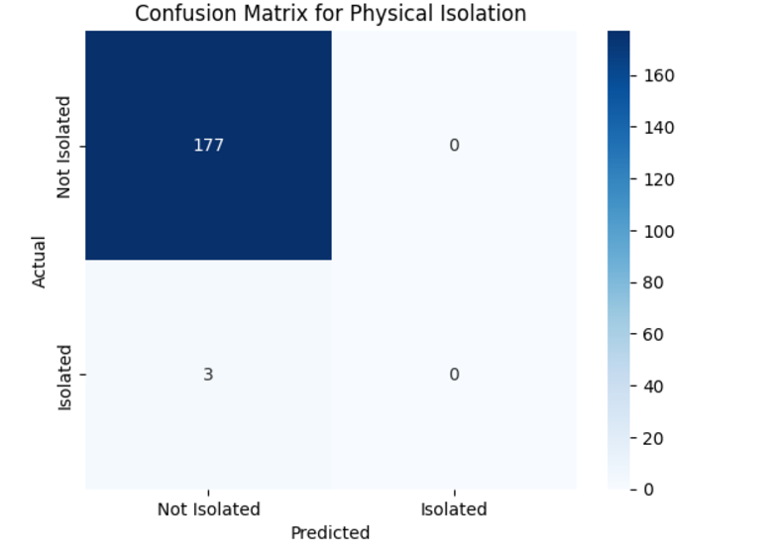

Fig. 1. Confusion Matrix 1

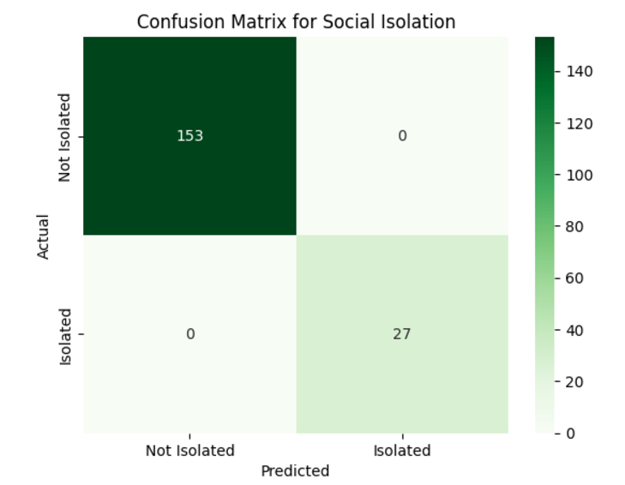

Fig. 2. Confusion Matrix 2

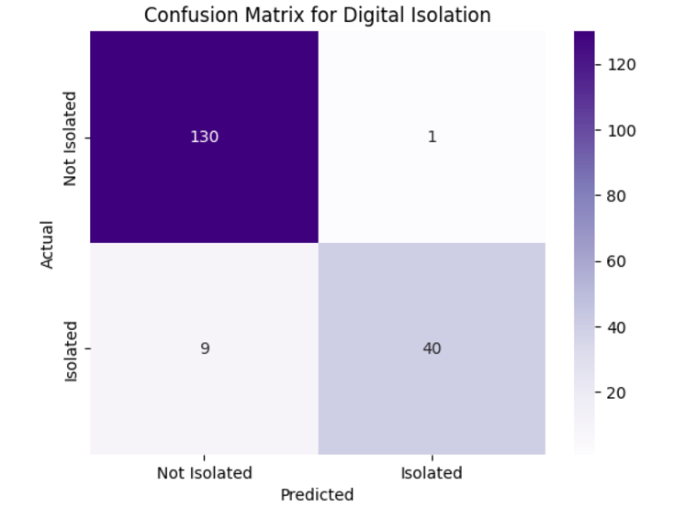

Fig. 3. Confusion Matrix 3

1. *Feature Importance Analysis*

Random Forest inherently calculates feature importance based on the Gini index or entropy reduction achieved by each feature across all trees. The top contributing features were

identified as:

* + **Screen Time (***Tscreen***):** Total time spent on devices.
  + **Social Interaction Frequency (***Finteraction***):** Frequency of interactions with others.
  + **Social Media Activity (***Csocial***):** Engagement level on social media platforms.

A bar plot was generated to visualize the importance of each feature, aiding in interpreting the model.

1. *Model Evaluation on Test Data*

The trained Random Forest model was evaluated on the test set, which was withheld during training. Key results included:

* + **Confusion Matrix:** A matrix displaying true positives, false positives, true negatives, and false negatives.
  + **ROC-AUC Curve:** The Receiver Operating Characteris- tic (ROC) curve was plotted, and the area under the curve (AUC) was calculated to assess the model’s ability to distinguish between isolated and non-isolated individuals.

1. *Comparison with Other Models*

The performance of the Random Forest classifier was com- pared with other machine learning models, such as:

* + **Support Vector Machines (SVM):** Evaluated for its performance on high-dimensional data.
  + **Convolutional Neural Networks (CNNs):** Used in a similar context for image-based feature extraction.
  + **Gradient Boosting Models (e.g., XGBoost):** Known for their high performance in tabular datasets.

The Random Forest classifier outperformed other models in terms of accuracy and interpretability.

1. *Model Optimization and Finalization*

After evaluation, the Random Forest model underwent fur- ther optimization:

* + **Pruning Unnecessary Features:** Features contributing less than 5% to overall importance were removed.
  + **Hyperparameter Fine-Tuning:** The best hyperparameter configuration was finalized to ensure optimal perfor- mance.
  + **Final Deployment:** The trained model was saved using standard serialization formats (e.g., Pickle, Joblib) for deployment in real-world applications.

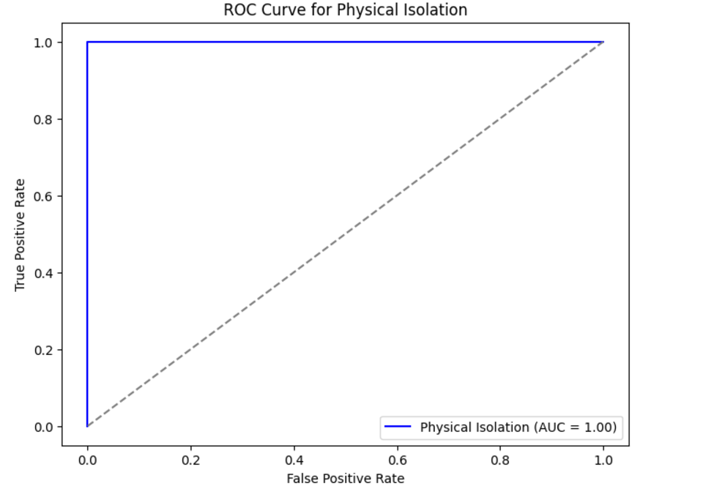

Fig. 4. ROC Curve 1

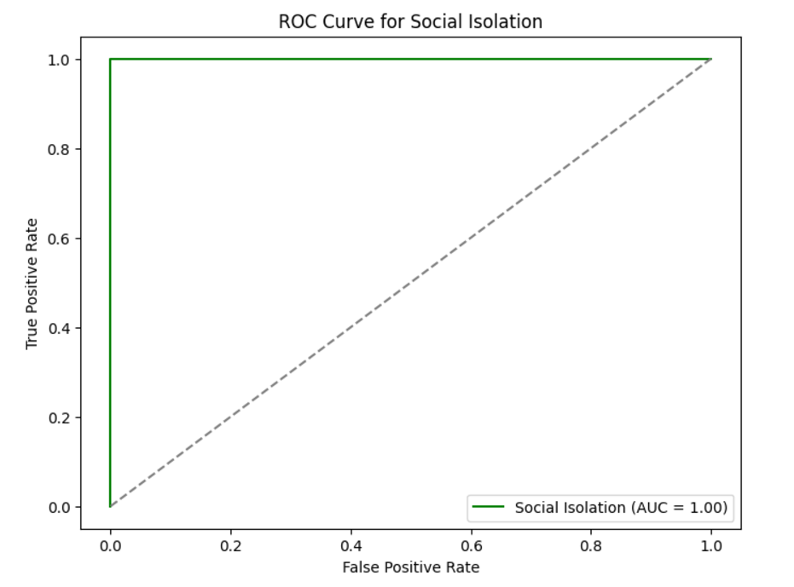

Fig. 5. ROC Curve 2

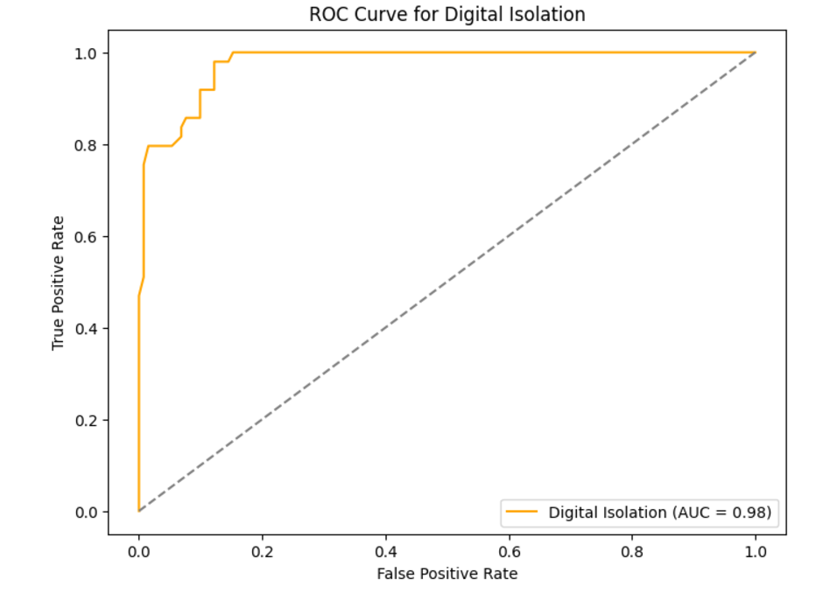

Fig. 6. ROC Curve 3

* + 1. FEATURE IMPORTANCE

One of the key advantages of the Random Forest algorithm is its ability to provide feature importance metrics. These metrics help identify which features (e.g., screen time, com- munication frequency, social interaction score, etc.) are the most influential in predicting social isolation.

The feature importance is calculated based on the reduction of impurity (e.g., Gini impurity or entropy) in the decision trees. The mathematical formula for calculating feature im- portance is given by:

*n*trees

Σ 1

Feature Importance = ∆*G*impurity

*n*trees *i*=1

Where:

* + ∆*G*impurity: The reduction in impurity for a given feature in each tree.
  + *n*trees: The total number of decision trees in the Random Forest model.

1. *Implementation in Python*

The following Python code calculates and visualizes the feature importance using the trained Random Forest model:

1. *Implementation in Python*

The Python implementation for calculating and visualizing feature importance using the Random Forest model is dis- cussed below. This involves the following steps:

* 1. *Dataset Preparation:* The dataset is loaded, and features such as screen_time, communication_frequency, social_interaction_score, and social_media_activity are identified as predictors. The target variable, isolation_status, indicates whether an individual is socially isolated. The data is split into training and testing sets using an 80-20 split ratio.
  2. *Model Training:* A Random Forest Classifier with 100 decision trees (n_estimators=100) is trained on the train- ing data. The classifier uses the Gini impurity criterion by default to evaluate splits within each tree.
  3. *Feature Importance Calculation:* The trained model cal- culates the importance of each feature based on its contribution to reducing impurity (Gini impurity or entropy) across all trees. The importance values are normalized to sum to 1.
  4. *Results Visualization:* The feature importance values are visualized using a bar plot, where each bar represents a feature and its corresponding importance value. The visualization highlights the most significant predictors of social isolation, providing insights into the model’s decision-making process.

1. *Key Observations*

* Features such as screen_time and communication_frequency were found to be the most significant in predicting isolation.
* Visualization of feature importance offers valuable in- sights into the model and helps interpret its behavior effectively.
* The feature importance plot is saved as a PNG image and included in this document as Figure **??**.

1. *Results and Insights*

The feature importance results are summarized as follows:

* Features like *screen time* and *communication frequency* showed the highest importance in predicting social isola- tion.
* A bar plot visualizing feature importance is presented in Figure **??**.
  + 1. XIV. MODEL DEPLOYMENT

Once the Random Forest model is trained and evaluated, it is crucial to deploy it in a real-world application to generate actionable predictions on social isolation. The deployment process ensures that the model is integrated into a system capable of handling real-time data input, prediction generation, and user feedback.

1. *System Integration*

The trained Random Forest model is serialized and integrated into a larger system that collects real- time behavioral data, such as screen_time and interaction_frequency. This system typically includes:

* + A backend server for data collection and model inference.
  + APIs to expose the prediction functionality to frontend applications.
  + A database to store historical user data and predictions for future analysis.

1. *Model Serialization*

To ensure the trained model can be easily deployed, it is serialized using efficient storage techniques. This allows the model to be loaded on a server for real-time predictions. Libraries such as Pickle or Joblib are commonly used for this purpose, ensuring compatibility with Python-based systems.

1. *Real-Time Prediction Pipeline*

The deployed model processes incoming data through a structured pipeline:

1. **Input Validation:** Ensures that the incoming data con- tains valid and complete feature values.
2. **Preprocessing:** Applies transformations consistent with the training phase, such as scaling or encoding categor- ical variables.
3. **Prediction:** Uses the Random Forest model to generate predictions on the social isolation status.
4. **Feedback Loop:** Captures user feedback to refine the model over time.
5. *User Interface*

A user-friendly interface is developed to present the model’s predictions in an accessible manner. Key features of the interface include:

* + Visual dashboards for tracking behavioral trends, such as screen time and interaction frequency.
  + Alerts and notifications to warn users about potential risks of social isolation.
  + Recommendations for improving social interaction based on the predictions.

1. *Continuous Monitoring and Updates*

The deployment system includes mechanisms for continu- ous monitoring and updates:

* + **Data Drift Detection:** Monitors the input data for changes in distribution that may impact model perfor- mance.
  + **Periodic Retraining:** The model is updated using newly collected data to maintain its accuracy.
  + **Performance Tracking:** Key performance metrics, such as accuracy, precision, and recall, are monitored in real- world applications to ensure the model meets expecta- tions.

1. *Implementation Overview*

The Random Forest model is deployed as part of a web- based application. A REST API framework, such as Flask or FastAPI, is used to handle incoming data and return predictions. The API performs the following tasks:

* + Accepts input data from the user or another system.
  + Preprocesses the data to match the model’s requirements.
  + Passes the data to the trained model for prediction.
  + Returns the prediction result in a user-friendly format.

This system architecture ensures that the model is accessible and can provide real-time predictions.

1. *Conclusion*

The deployment process enables the Random Forest model to become an effective tool in detecting social isolation. By integrating the model into a scalable system with continuous monitoring and updates, it provides actionable insights and ensures long-term relevance and reliability.

* + 1. XV. RESULTS INTERPRETATION AND ACTIONABLE INSIGHTS

The Random Forest model predictions are leveraged not only for detecting social isolation but also for deriving ac- tionable insights that can guide interventions and improve well-being. This section outlines how the predictions are interpreted, how they inform actionable strategies, and future improvements to enhance the model’s utility.

1. *Interpreting Predictions*

The model classifies individuals based on their likelihood of being socially isolated. The results are categorized into actionable labels:

* + **Isolated:** Indicates that an individual is likely experi- encing social isolation. This is a call for immediate intervention.
  + **At Risk:** Suggests that an individual may be at risk of social isolation, requiring proactive measures to prevent further decline.
  + **Engaged:** Represents a healthy level of social interaction and indicates no immediate action is required.

The classification outcomes are presented in a user-friendly format, such as visual dashboards or textual summaries, to ensure clarity for users and stakeholders.

1. *Actionable Recommendations*

When an individual is identified as isolated or at risk, the system generates tailored recommendations, which may include:

* + **Social Interaction Suggestions:** Encouraging more fre- quent interactions with family, friends, or community groups.
  + **Behavioral Monitoring:** Advising close monitoring of behavioral patterns, such as changes in screen time or reduced communication frequency.
  + **Mental Health Resources:** Providing links to profes- sional resources, such as counseling or support groups, for individuals requiring additional help.
  + **Activity Recommendations:** Suggesting activities that promote engagement, such as participating in local events or reducing excessive screen time.

1. *Model Limitations and Future Improvements*

While the current Random Forest model achieves high accuracy, there are areas for potential enhancement:

* + **Incorporating Additional Features:** Future work may include integrating new features, such as geolocation data, exercise frequency, or psychological survey responses, to improve prediction accuracy.
  + **Algorithm Comparison:** Experimenting with advanced machine learning algorithms, such as Gradient Boosting Machines or Neural Networks, to assess their perfor- mance relative to Random Forest.
  + **Hyperparameter Tuning:** Conducting further optimiza- tion of hyperparameters to improve model performance.
  + **Addressing Bias:** Ensuring the dataset is representative to minimize biases in predictions and enhance fairness across diverse user groups.
  + **Temporal Modeling:** Incorporating time-series data to understand behavioral trends and predict social isolation over time.

1. *Real-World Application and Impact*

The insights derived from the model have significant real- world applications, such as:

* + **Proactive Interventions:** Helping organizations and in- dividuals take preventive actions before social isolation becomes severe.
  + **Policy Development:** Informing policymakers about trends in social isolation within communities and guiding resource allocation.
  + **Community Engagement Programs:** Designing tar- geted programs to enhance community interactions based on aggregated insights from the model.

1. *Conclusion*

The results generated by the Random Forest model serve as a powerful tool for understanding and addressing social isolation. By combining predictive analytics with actionable recommendations, the system can positively impact individuals and communities. Continuous improvements to the model will further enhance its reliability and effectiveness, ensuring it remains a valuable resource for addressing social isolation.

article hyperref url

1. Springer, ”Enhancing Social Behavior Prediction Using Random Forest.” [Online]. Available: [https://link.springer.com/article/10.1007/](https://link.springer.com/article/10.1007/s11222-012-9349-1) [s11222-012-9349-1](https://journals.sagepub.com/doi/abs/10.1177/23337214231201204)
2. ResearchGate, ”Predicting Hostel Room Alloca- tion Using Random Forest.” [Online]. Available: [https://www.researchgate.net/profile/Manish-Tiwari-44/](https://www.researchgate.net/profile/Manish-Tiwari-44/publication/378496263/links/65dd7907e7670d36abe2a409/Study-of-Hostel-Room-Allocation-Using-Random-Forest-Algorithm.pdf) [publication/378496263/links/65dd7907e7670d36abe2a409/](mailto:jyothiswaroopa.kc2022@vitstudent.ac.in)

[Study-of-Hostel-Room-Allocation-Using-Random-Forest-Algorithm.](mailto:krithiga.r@vit.ac.in) [pdf](https://www.researchgate.net/profile/Manish-Tiwari-44/publication/378496263/links/65dd7907e7670d36abe2a409/Study-of-Hostel-Room-Allocation-Using-Random-Forest-Algorithm.pdf)

1. ScienceDirect, ”Impact of Digital Isolation on Social Connectiv- ity.” [Online]. Available: [https://www.sciencedirect.com/science/article/](mailto:anth.sai2022@vitstudent.ac.in) [pii/S0165032719321937](https://www.sciencedirect.com/science/article/pii/S0165032719321937)
2. ScienceDirect, ”Social Media and Digital Isolation.” [Online]. Available: [https://www.sciencedirect.com/science/article/pii/S0169136818303627](https://www.researchgate.net/profile/Manish-Tiwari-44/publication/378496263/links/65dd7907e7670d36abe2a409/Study-of-Hostel-Room-Allocation-Using-Random-Forest-Algorithm.pdf)
3. DUO, ”Social Behavior Analysis Using Random Forest.” [Online].

Available: [https://www.duo.uio.no/handle/10852/104077](https://www.researchgate.net/profile/Manish-Tiwari-44/publication/378496263/links/65dd7907e7670d36abe2a409/Study-of-Hostel-Room-Allocation-Using-Random-Forest-Algorithm.pdf)

1. SAGE Journals, ”Social Isolation and Engagement Prediction Mod- els.” [Online]. Available: [https://journals.sagepub.com/doi/abs/10.1177/](https://journals.sagepub.com/doi/abs/10.1177/0142331217708242) [0142331217708242](https://www.sciencedirect.com/science/article/pii/S0169136818303627)

REFERENCES

1. MDPI, ”Machine Learning Algorithms for Behavioral Prediction.” [On- line]. Available: [https://www.mdpi.com/2076-328X/14/10/947](mailto:aroopa.kc2022@vitstudent.ac.in)
2. ScienceDirect, ”Predictive Modeling with Random Forests.” [Online]. Available: [https://www.sciencedirect.com/science/article/](https://www.sciencedirect.com/science/article/pii/B9780323911962000119) [pii/B9780323911962000119](https://www.sciencedirect.com/science/article/pii/S0165032719321937)
3. IOPscience, ”Analysis of Behavioral Data Using Random Forest.” [On- line]. Available: [https://iopscience.iop.org/article/10.1088/1742-6596/](https://iopscience.iop.org/article/10.1088/1742-6596/2161/1/012021/meta) [2161/1/012021/meta](https://journals.sagepub.com/doi/abs/10.1177/0142331217708242)
4. Tandfonline, ”Mental Health Prediction Using Machine Learning.” [On- line]. Available: [https://www.tandfonline.com/doi/abs/10.2147/RMHP.](https://www.duo.uio.no/handle/10852/104077)

[S297838](https://www.tandfonline.com/doi/abs/10.2147/RMHP.S297838)

1. APA PsycNet, ”Behavioral Analysis Using Random Forests in Psychology.” [Online]. Available: [https://psycnet.apa.org/record/](https://www.sciencedirect.com/science/article/pii/B9780323911962000119) [2009-22665-002](https://psycnet.apa.org/record/2009-22665-002)
2. Springer, ”Predicting Social Isolation Using Machine Learning.” [Online]. Available: [https://link.springer.com/article/10.1007/](https://link.springer.com/article/10.1007/s10964-023-01926-z) [s10964-023-01926-z](https://link.springer.com/article/10.1007/s11222-012-9349-1)
3. ScienceDirect, ”Impact of Social Media on Behavioral Isolation.” [Online]. Available: [https://www.sciencedirect.com/science/article/pii/](https://www.sciencedirect.com/science/article/pii/S2772662223001753) [S2772662223001753](https://iopscience.iop.org/article/10.1088/1742-6596/2161/1/012021/meta)
4. ACM, ”Prediction of Social Isolation Through Machine Learning.” [Online]. Available: [https://dl.acm.org/doi/abs/10.1145/3178582](https://www.mdpi.com/2076-328X/14/10/947)
5. SAGE Journals, ”Social Behavior and Isolation Predictive Model- ing.” [Online]. Available: [https://journals.sagepub.com/doi/abs/10.1177/](https://journals.sagepub.com/doi/abs/10.1177/23337214231201204) [23337214231201204](https://psycnet.apa.org/record/2009-22665-002)
6. Wiley, ”Prediction of Isolation Based on Social Behavior.” [On- line]. Available: [https://onlinelibrary.wiley.com/doi/abs/10.1155/2022/](https://onlinelibrary.wiley.com/doi/abs/10.1155/2022/2670562) [2670562](https://www.sciencedirect.com/science/article/pii/S2772662223001753)
7. ScienceDirect, ”Modeling Isolation Using Machine Learning Tech- niques.” [Online]. Available: [https://www.sciencedirect.com/science/](https://www.tandfonline.com/doi/abs/10.2147/RMHP.S297838) [article/pii/S1053811917310686](https://www.sciencedirect.com/science/article/pii/S1053811917310686)
8. Tandfonline, ”Analyzing Social Behavior through Machine Learning Algorithms.” [Online]. Available: [https://www.tandfonline.com/doi/abs/](mailto:gunnam.deekshitha2022@vitstudent.ac.in) [10.1080/00330124.2021.1970591](https://dl.acm.org/doi/abs/10.1145/3178582)
9. IEEE, ”Applications of Random Forest in Social Isolation Predic- tion.” [Online]. Available: [https://ieeexplore.ieee.org/abstract/document/](https://ieeexplore.ieee.org/abstract/document/9871331/) [9871331/](https://link.springer.com/article/10.1007/s10964-023-01926-z)
10. ScienceDirect, ”Social Isolation and Digital Behavior Prediction.” [Online]. Available: [https://www.sciencedirect.com/science/article/pii/](https://www.sciencedirect.com/science/article/pii/S001393512202494X) [S001393512202494X](https://onlinelibrary.wiley.com/doi/abs/10.1155/2022/2670562)